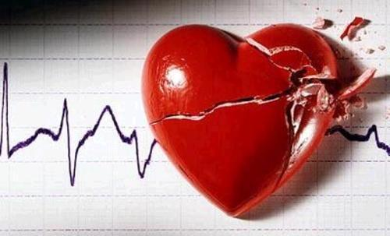
The Love Hurts VD Hash. Cum dressed in red or black (whips and handcuffs optional). Celebrate Cupid Day or Curse it. Bring a love poem or a vengeful tirade. You decide. On on at Double D and Dash’s 401 Lewisham St. There will be grub on after and possibly chocolate, if Dash doesn’t eat it first.

